**PYTHON LAB 5**

**NAME: ANGELINE A**

**REG NO: 2348409**

**INHERITANCE**

1. **CODE:**

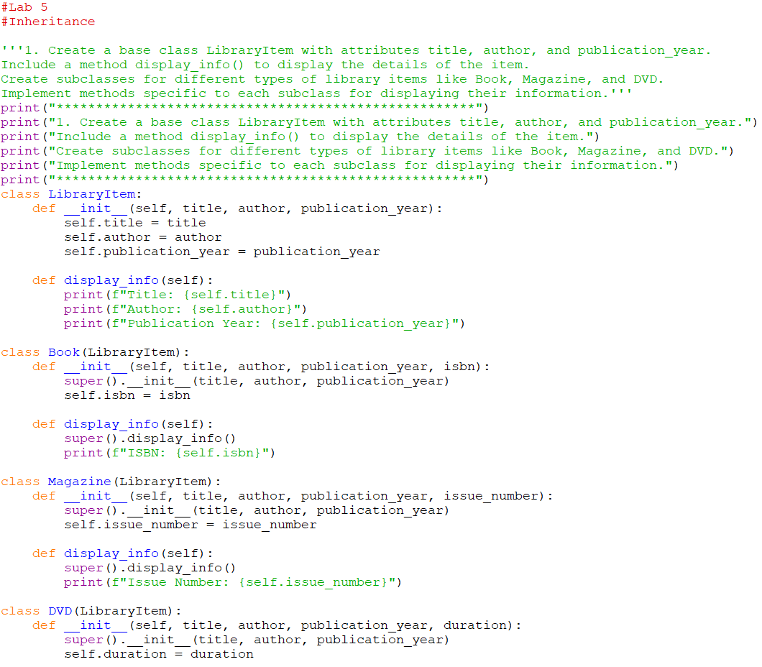

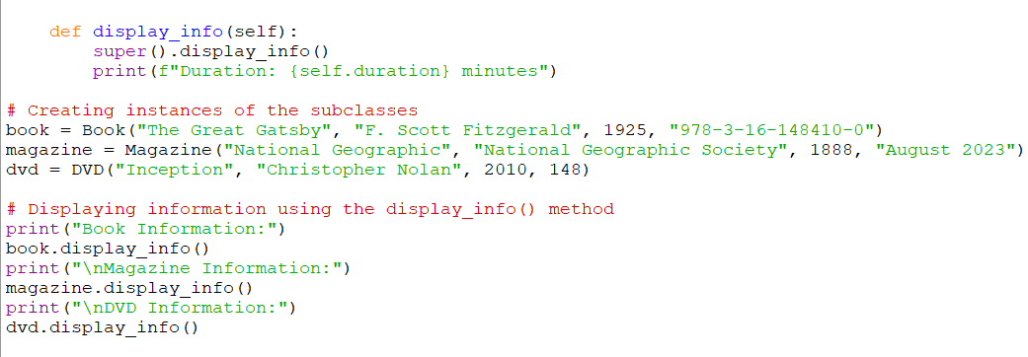

**OUTPUT:  
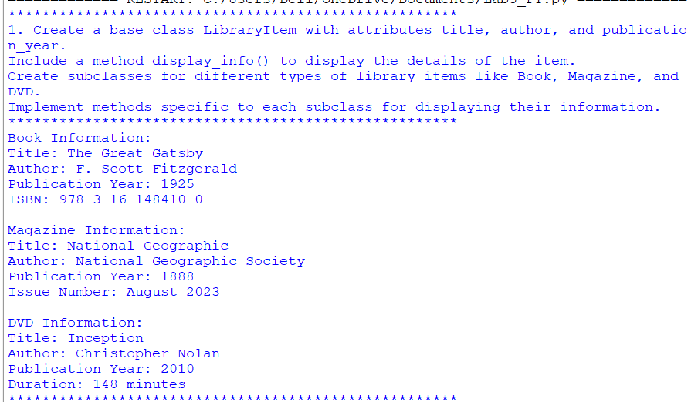**

1. **CODE:  
   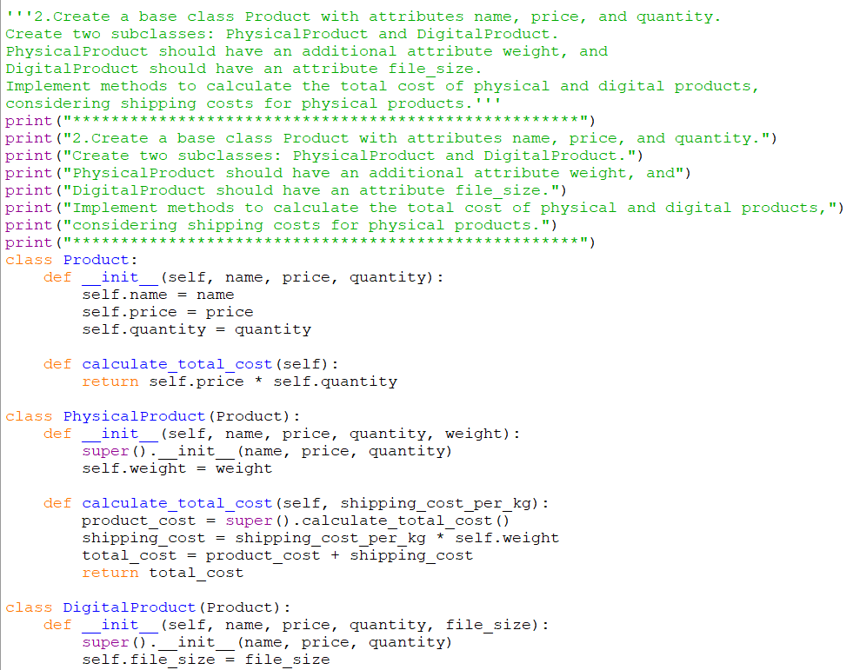**

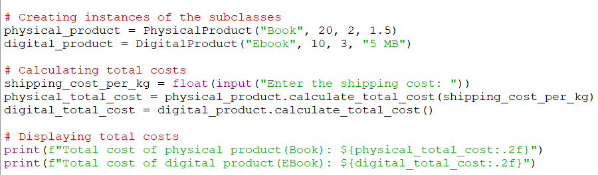

**OUTPUT:**

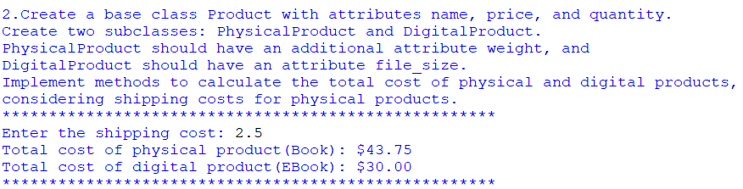

**EXCEPTIONAL HANDLING**

1. **CODE:**

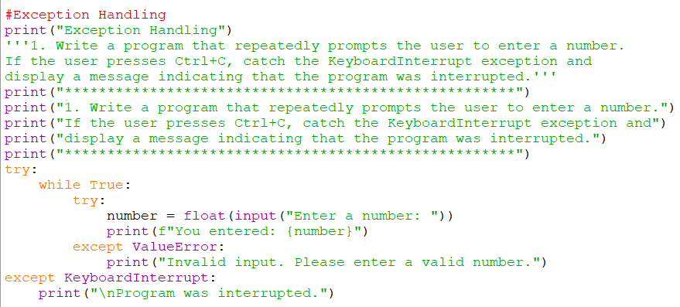

**OUTPUT:**

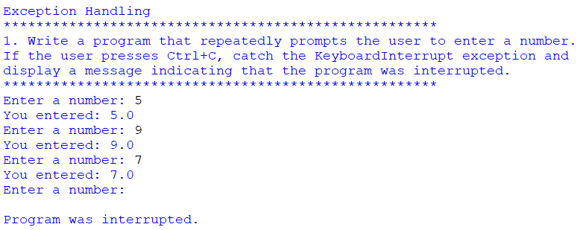

1. **CODE:**

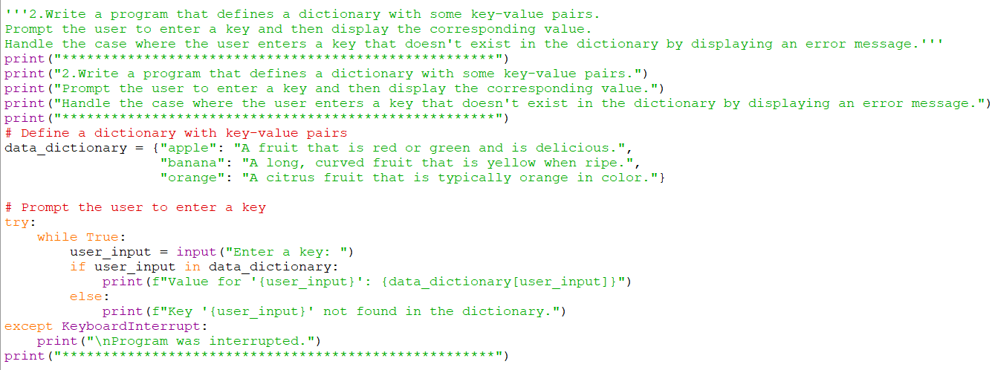

**OUTPUT:**

